Azure Data Lake Storage Gen2 (ADLS Gen2)
1. Storage Architecture

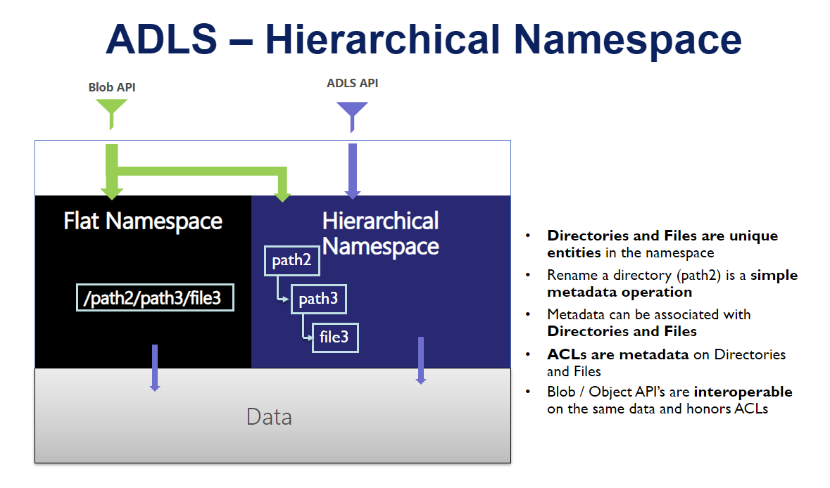
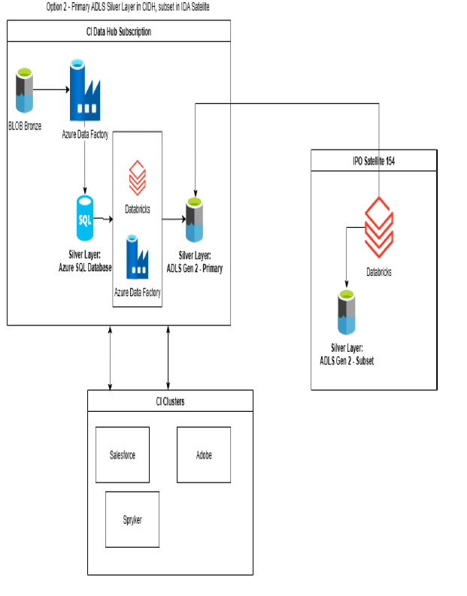
Key Concepts
- Built on top of Microsoft Azure Blob Storage
- Supports Hierarchical Namespace (HNS) → enables directory structure
- Combines:
  - Data Lake capabilities (analytics)
  - Blob storage (scalability + durability)
Architecture Components
- Storage Account
- Containers (File Systems)
- Directories & Files
- Access Layer (REST APIs, SDKs)
Benefits
- Massively scalable (PB-level)
- High throughput for analytics workloads
- Fine-grained access control (POSIX-like ACLs)

2. Containers & Hierarchy
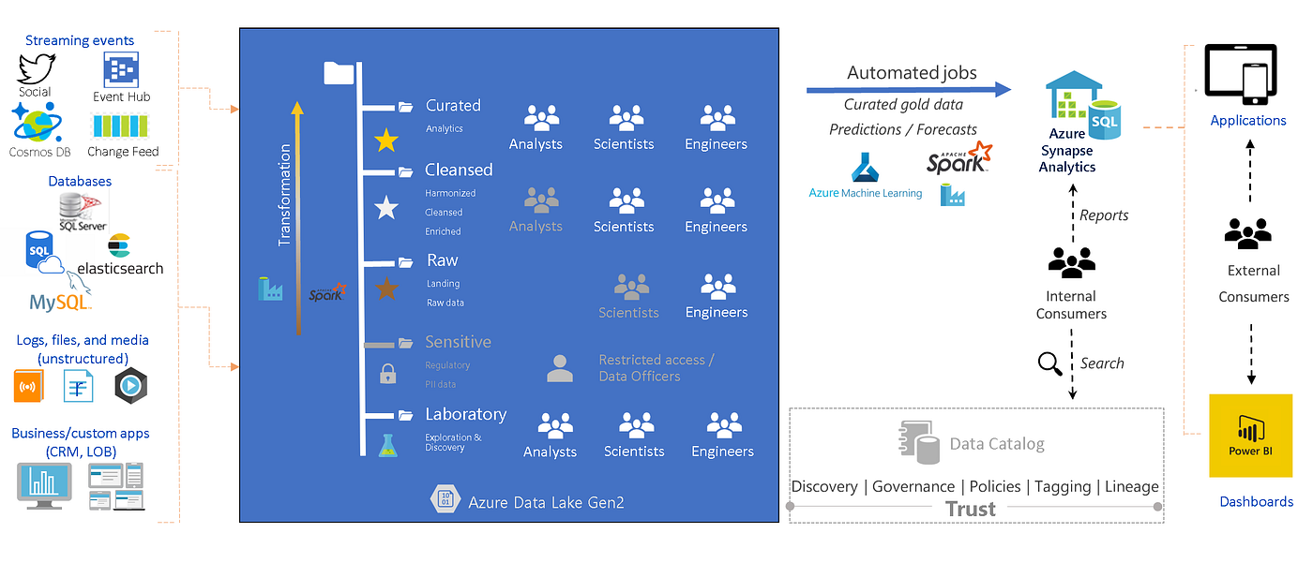
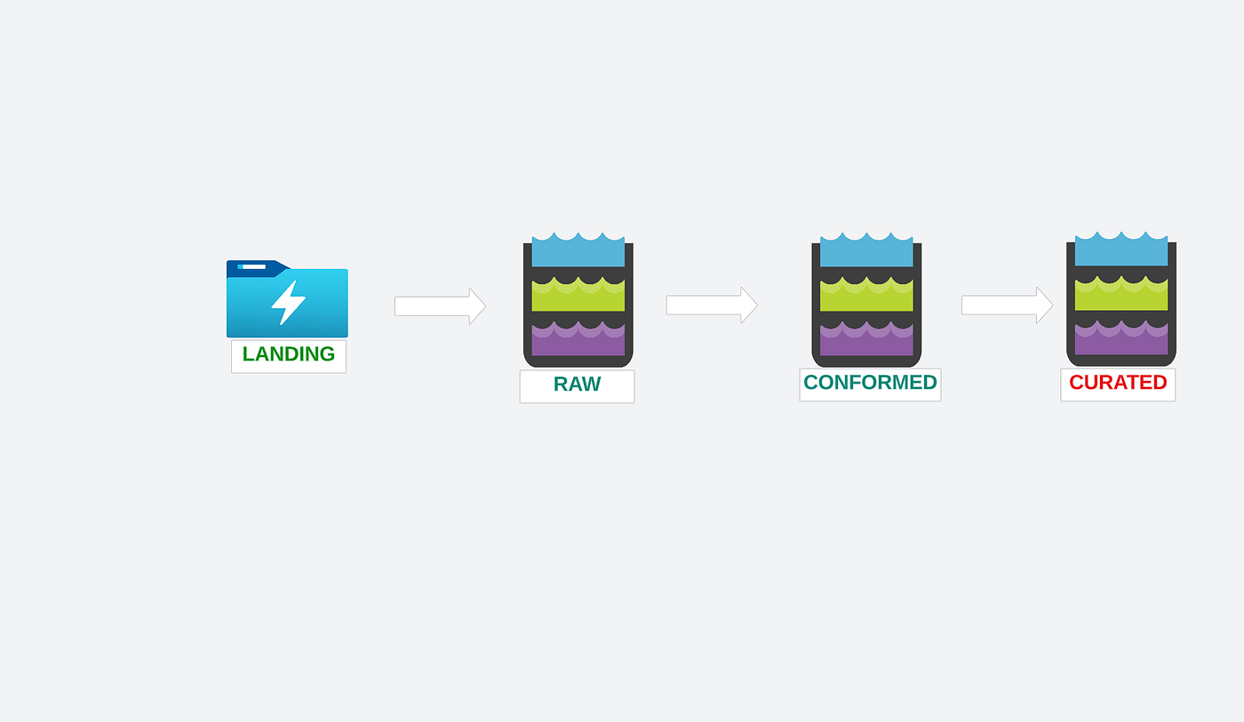
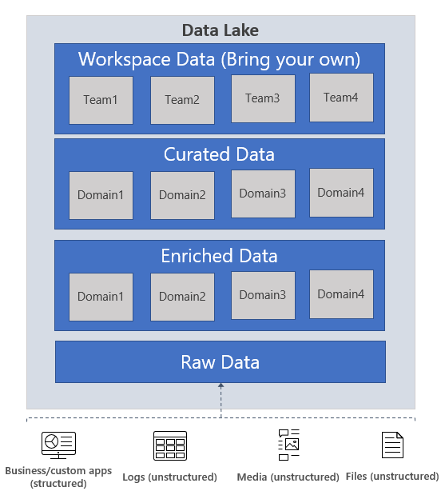
Structure
Storage Account
└── Container (File System)
├── Directory (Folder)
│ ├── Sub-directory
│ └── Files
Best Practices
- Use multiple containers for isolation:
  - raw
  - processed
  - curated
- Avoid deep nesting (>5 levels)
- Use consistent naming:
  - lowercase
  - no spaces (use _ or -)

3. Access Methods
1. Access Keys
- Full control over storage account
- Not recommended for production (security risk)
2. SAS (Shared Access Signature)
- Temporary, time-bound access
- Types:
  - Service SAS
  - Account SAS
3. Service Principal (App Registration)
- Used for automation & pipelines
- Integrated with Azure AD
4. Managed Identity
- Best practice for Azure services
- No credential management required
Comparison
Method | Security | Use Case
Keys | Low | Testing
SAS | Medium | Temporary sharing
Service Principal | High | CI/CD, apps
Managed Identity | Very High | Azure-native services

4. Lifecycle Management

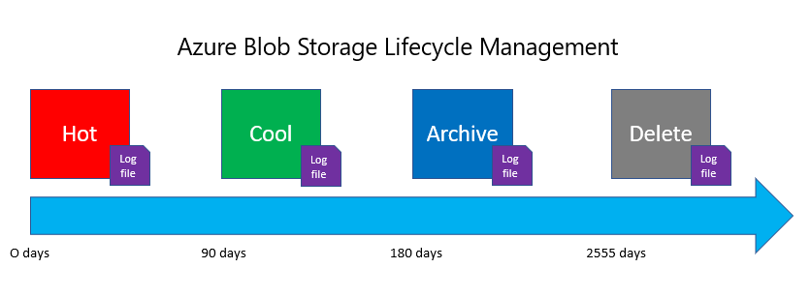
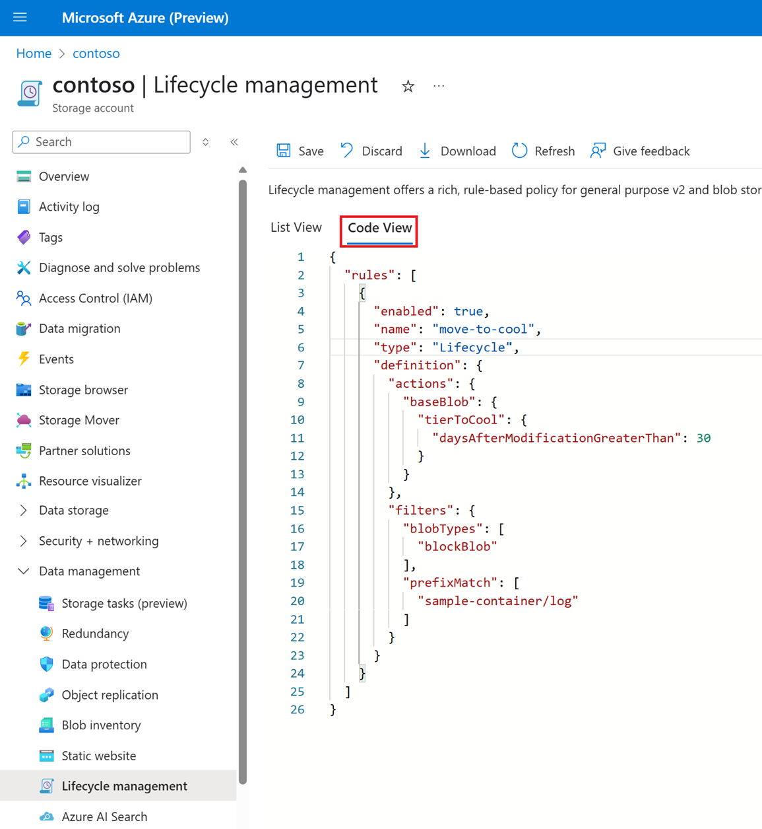
Purpose
Automate data movement across tiers:
- Hot → frequent access
- Cool → infrequent
- Archive → rarely used
Example Policy
- Move data to Cool after 30 days
- Archive after 90 days
- Delete after 365 days
Benefits
- Cost optimization
- Data retention compliance

5. Encryption Basics
Types of Encryption
- At Rest
  - Microsoft-managed keys (default)
  - Customer-managed keys (CMK via Key Vault)
- In Transit
  - HTTPS / TLS encryption
Key Concepts
- Encryption is automatic
- Use Azure Key Vault for CMK
- Supports double encryption for compliance

6. Data Lake Folder Design Patterns
Common Patterns
1. Raw Layer (Landing Zone)
/raw/source_name/year/month/day/file.json
2. Partitioned Data
/sales/year=2025/month=03/day=30/
3. Domain-Based Structure
/finance/
/hr/
/sales/
Best Practices
- Partition by:
  - date (most common)
  - region
  - business unit
- Avoid small files problem
- Use consistent schema evolution strategy

Module 5 — Lakehouse Architecture in Azure
1. ADLS + Databricks Integration Model
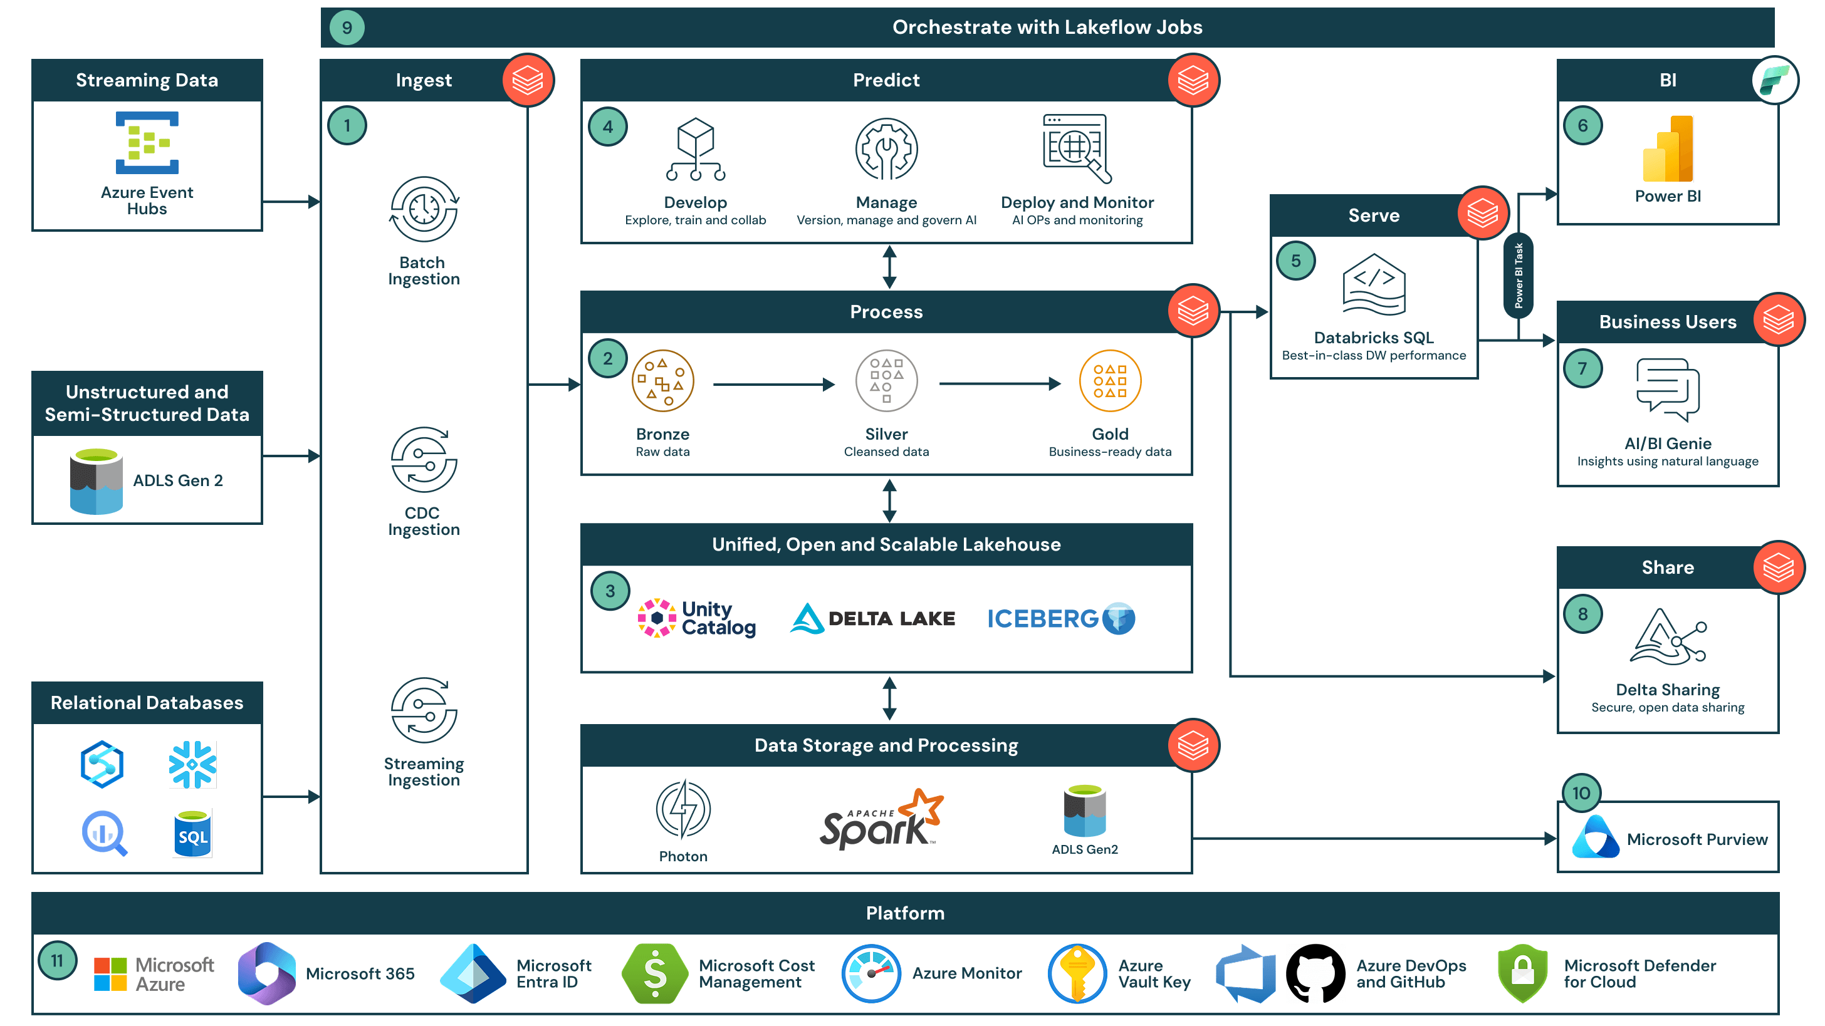
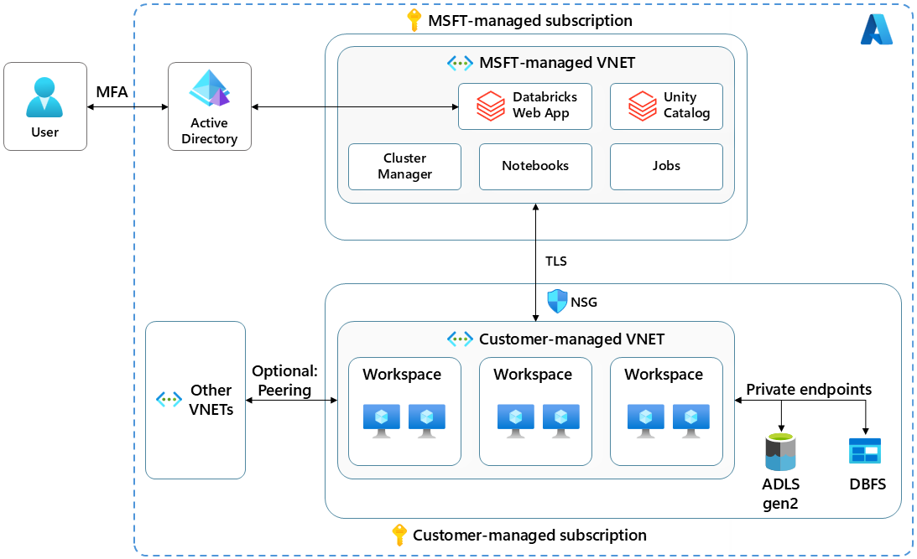
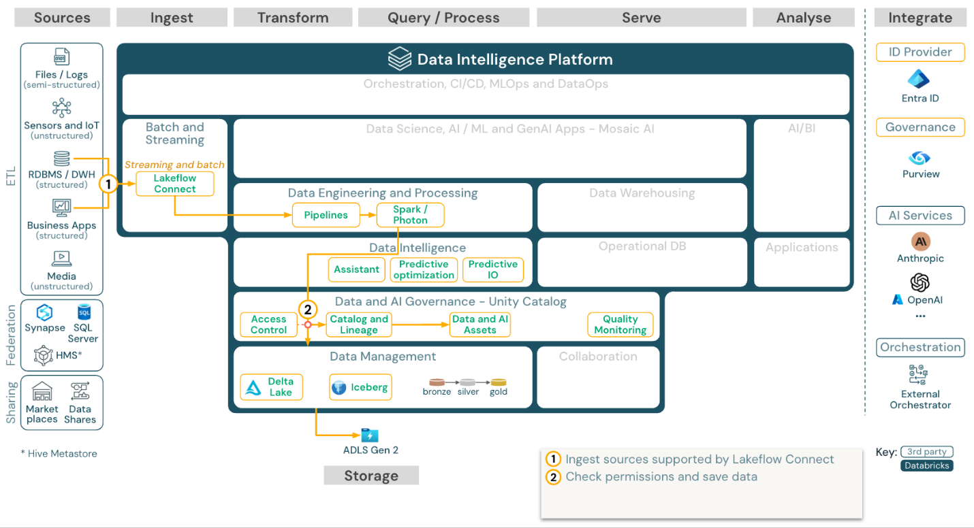
4
Core Components
- Azure Databricks
- ADLS Gen2 (Storage Layer)
- Unity Catalog / Access Control
Integration Methods
- Mount ADLS using:
  - Service Principal
  - Managed Identity
- Access via:
  - ABFS protocol (abfss://)

2. Bronze → Silver → Gold Architecture

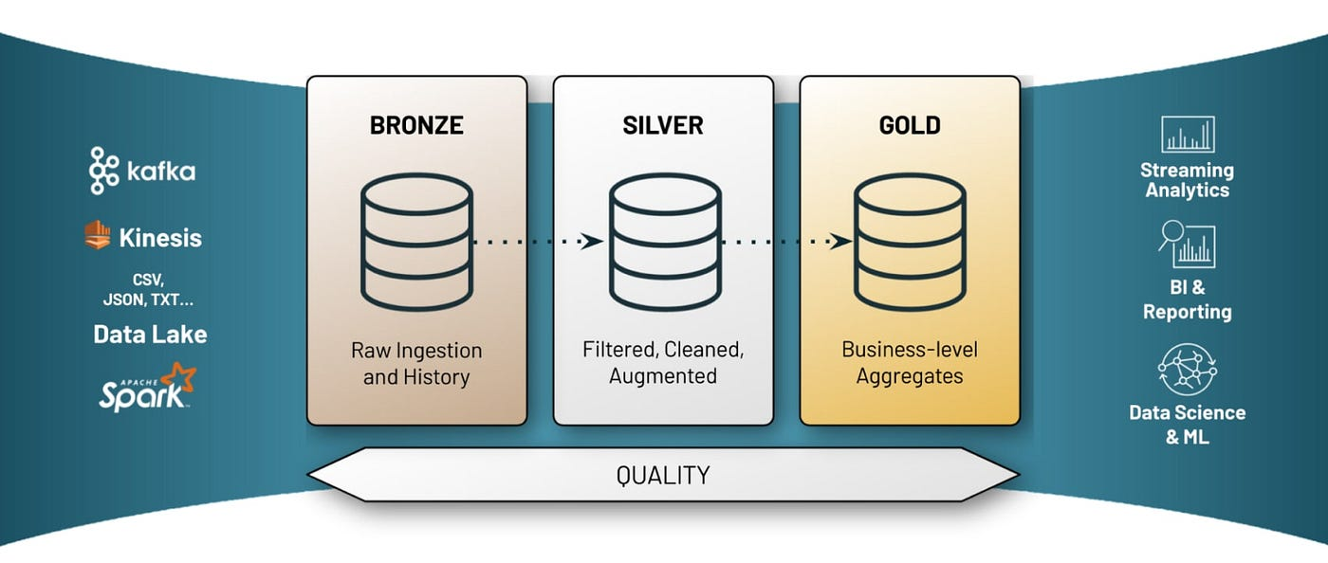
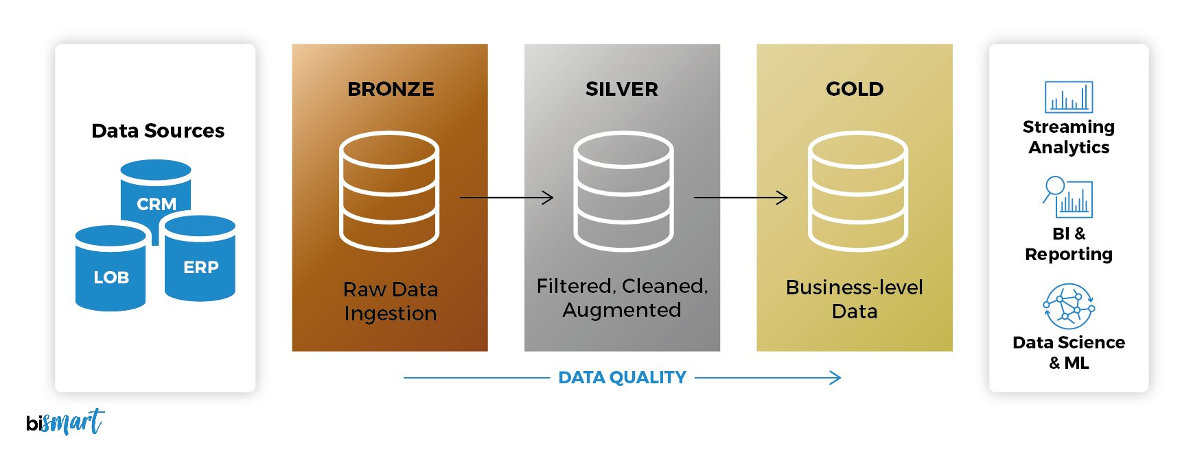
4
Layers Explained
Bronze (Raw Data)
- Ingested as-is
- No transformation
- Source of truth
Silver (Cleaned Data)
- Data cleaning
- Deduplication
- Schema enforcement
Gold (Curated Data)
- Business-level aggregates
- Reporting-ready datasets
Example Flow
Raw JSON → Cleaned Tables → Aggregated Reports

3. Cost-Aware Storage Design
Cost Factors
- Storage tier (Hot/Cool/Archive)
- Transaction costs
- Data egress
Optimization Techniques
- Use partition pruning
- Store in Parquet/Delta format
- Compress data (Snappy)
Recommendations
- Keep Bronze in cheaper storage
- Use lifecycle policies
- Avoid unnecessary duplication

4. Performance Considerations
Key Factors
File Size Optimization
- Ideal: 100 MB – 1 GB per file
- Avoid:
  - Too many small files
  - Very large single files
Partitioning Strategy
- Good:
  - date-based
- Bad:
  - high-cardinality columns (e.g., user_id)
Delta Lake Optimization
- Use:
  - OPTIMIZE
  - ZORDER
  - VACUUM
Caching
- Use Databricks caching for repeated queries

